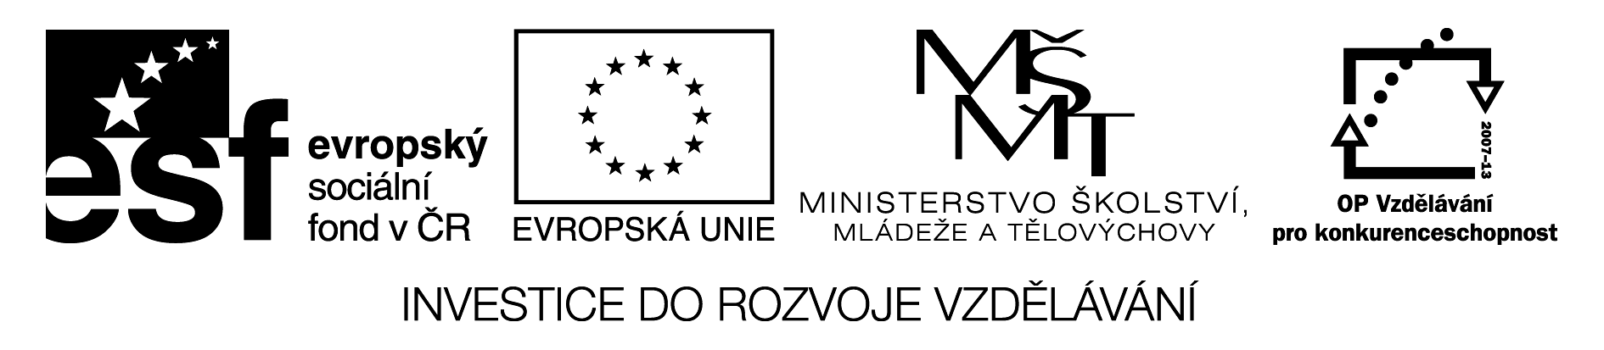

countable and uncountable nouns

1. Translate

dvě tabulky čokolády …………………………………………………………………………...
tři lahve limonády ………………………………………………………………………………
čtyři misky polévky …………………………………………………………………………….
dva šálky kávy …………………………………………………………………………………..
12 kartonů mléka ……………………………………………………………………………......
tři kila masa ……………………………………………………………………………………..
osm bochníků chleba…………………………………………………………………………….
dva kousky koláče ………………………………………………………………………………
6 krabiček čaje ………………………………………………………………………………….
5 plátků chleba …………………………………………………………………………………
3 plechovky koly ………………………………………………………………………………..
2. Complete the sentences with a or an where necessary and translate them:
Can I have _______ orange, please?
Do you like _______fish?
I usually have _______egg for breakfast.
I don´t eat _______ meat.
We always have _________tomatoes with our dinner.
I had _______ apple and ________ banana today.
I love ________ fruit, but I don´t like ___vegetables.
Can I have _____ sandwich, please, with _____ cheese and _____ lettuce?

countable and uncountable nouns

1. Translate

dvě tabulky čokolády two bars of chocolate
tři lahve limonády three bottles of lemonada
čtyři misky polévky four bowls of soup
dva šálky kávy two cups of tea
12 kartonů mléka 12 cartons of milk
tři kila masa three kilos of meat
osm bochníků chleba eight loafs of breat
dva kousky koláče two pieces of cake
6 krabiček čaje six packets of tea
5 plátků chleba five slices of bread
3 plechovky koly three tins of Coke
2. Complete the sentences with a or an where necessary and translate them:
Can I have __an____ orange, please?
Do you like ___a____fish?
I usually have ____an___egg for breakfast.
I don´t eat ___Ø____ meat.
We always have ____some_____tomatoes with our dinner.
I had ___an____ apple and ___a_____ banana today.
I love ____Ø____ fruit, but I don´t like _Ø__vegetables.
Can I have ___a__ sandwich, please, with __Ø___ cheese and ___a__ lettuce?

